$\left(110\right)$**Oriented Substrate**

We assume our film is grown epitaxial and develops coherent lattice mismatches with the substrate. For a substrate that is oriented such that $\left(101\right)$ plane is normal to the $x_{3}$ global axis direction. For a cubic structure, the $\left(101\right)$ plane is equivalent to the $\left(110\right)$ plane.

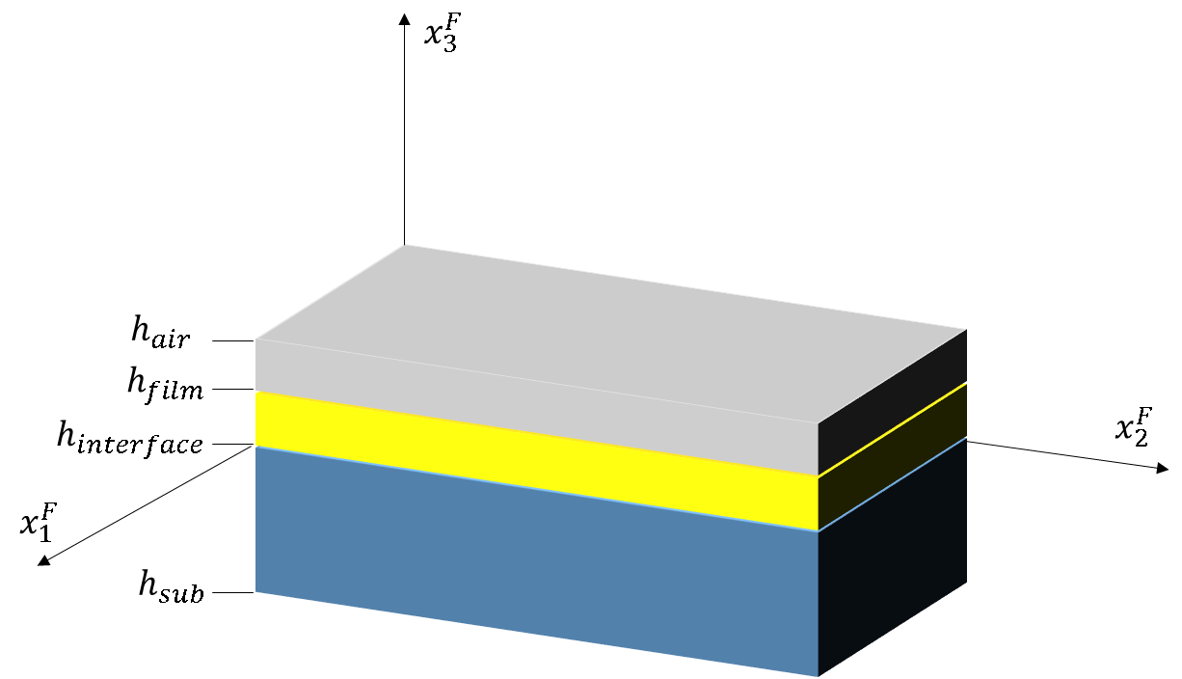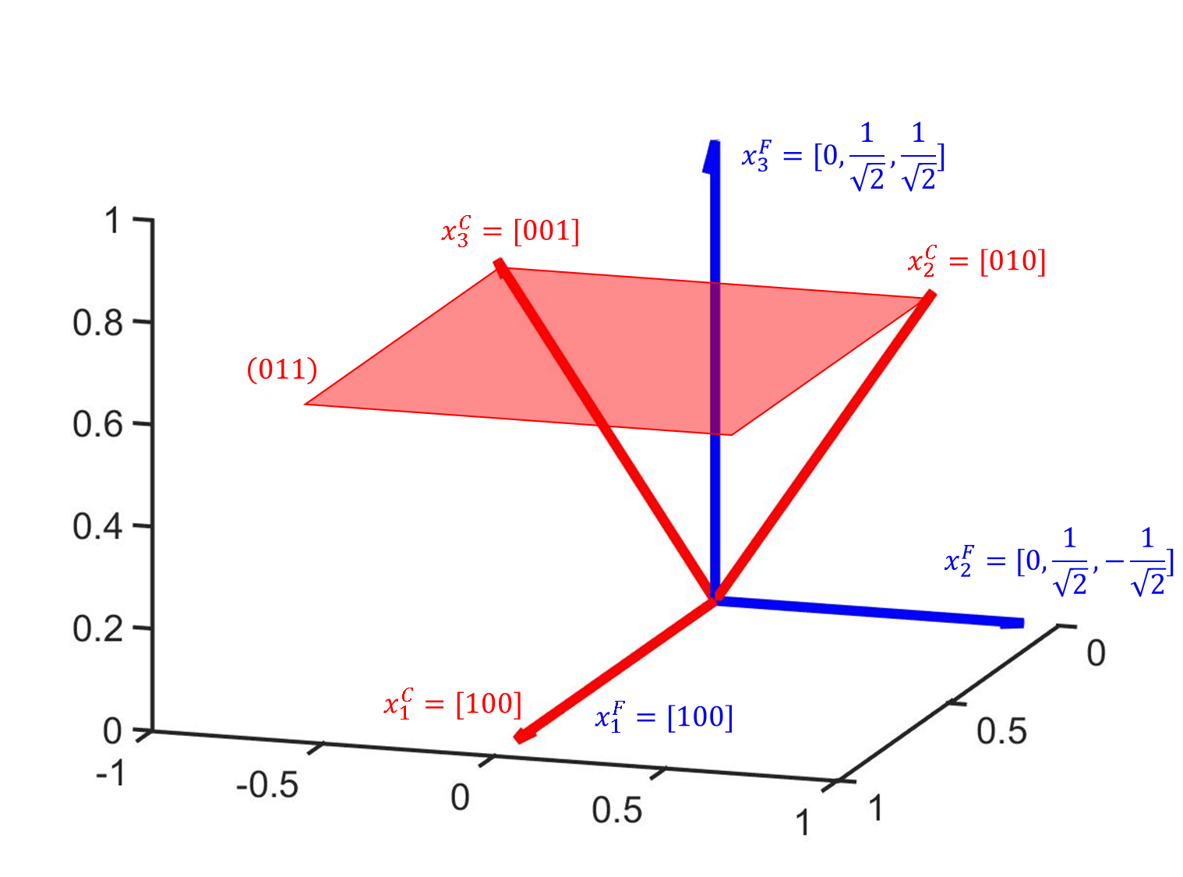

The rotation matrix for an angle $θ$ about the x-axis counter-clockwise is:

$$R_{x}\left(θ\right)=\left(\begin{matrix}1 & 0 & 0 \\ 0 & cos\left(θ\right) & \sin\left(θ\right) \\ 0 & -\sin\left(θ\right) & \cos\left(θ\right)\end{matrix}\right)$$

The transformation matrix from global reference frame $\left(x_{i}^{F}\right)$ to the crystal reference frame $\left(x_{i}^{C}\right)$ is:

$$T^{-1}=R_{x}\left(θ=\frac{π}{4}\right)=\left(\begin{matrix}1 & 0 & 0 \\ 0 & \frac{1}{\sqrt{2}} & \frac{1}{\sqrt{2}} \\ 0 & -\frac{1}{\sqrt{2}} & \frac{1}{\sqrt{2}}\end{matrix}\right)$$

The transformation matrix from the crystal reference frame to the global reference frame is:

$$T=T_{ij}=\left(\begin{matrix}1 & 0 & 0 \\ 0 & \frac{1}{\sqrt{2}} & -\frac{1}{\sqrt{2}} \\ 0 & \frac{1}{\sqrt{2}} & \frac{1}{\sqrt{2}}\end{matrix}\right)$$

The Landau energy will transform as:

$$f_{l}=α_{1}^{s}\left({\left(P_{1}^{C}\right)}^{2}+{\left(P_{2}^{C}\right)}^{2}+{\left(P_{3}^{C}\right)}^{2}\right)+α_{11}^{s}\left({\left(P_{1}^{C}\right)}^{4}+{\left(P_{2}^{C}\right)}^{4}+{\left(P_{3}^{C}\right)}^{4}\right)+α_{12}^{s}\left({\left(P_{1}^{C}\right)}^{2}{\left(P_{2}^{C}\right)}^{2}+{\left(P_{1}^{C}\right)}^{2}{\left(P_{3}^{C}\right)}^{2}+{\left(P_{2}^{C}\right)}^{2}{\left(P_{3}^{C}\right)}^{2}\right)+α_{111}^{s}\left({\left(P_{1}^{C}\right)}^{6}+{\left(P_{2}^{C}\right)}^{6}+{\left(P_{3}^{C}\right)}^{6}\right)+α_{112}^{s}\left({\left(P_{1}^{C}\right)}^{4}\left({\left(P_{2}^{C}\right)}^{2}+{\left(P_{3}^{C}\right)}^{2}\right)+{\left(P_{2}^{C}\right)}^{4}\left({\left(P_{1}^{C}\right)}^{2}+{\left(P_{3}^{C}\right)}^{2}\right)+{\left(P_{3}^{C}\right)}^{4}\left({\left(P_{1}^{C}\right)}^{2}+{\left(P_{2}^{C}\right)}^{2}\right)\right)+α_{123}^{s}\left({\left(P_{1}^{C}\right)}^{2}{\left(P_{2}^{C}\right)}^{2}{\left(P_{3}^{C}\right)}^{2}\right)+α_{1111}^{s}\left({\left(P_{1}^{C}\right)}^{8}+{\left(P_{2}^{C}\right)}^{8}+{\left(P_{3}^{C}\right)}^{8}\right)+α_{1112}^{s}\left({\left(P_{1}^{C}\right)}^{6}\left({\left(P_{2}^{C}\right)}^{2}+{\left(P_{3}^{C}\right)}^{2}\right)+P_{2}^{6}\left({\left(P_{1}^{C}\right)}^{2}+{\left(P_{3}^{C}\right)}^{2}\right)+P_{3}^{6}\left({\left(P_{1}^{C}\right)}^{2}+{\left(P_{2}^{C}\right)}^{2}\right)\right)+α_{1122}^{s}\left({\left(P_{1}^{C}\right)}^{4}{\left(P_{2}^{C}\right)}^{4}+{\left(P_{2}^{C}\right)}^{4}{\left(P_{3}^{C}\right)}^{4}+{\left(P_{1}^{C}\right)}^{4}{\left(P_{3}^{C}\right)}^{4}\right)+α_{1123}^{s}\left({\left(P_{1}^{C}\right)}^{4}{\left(P_{2}^{C}\right)}^{2}{\left(P_{3}^{C}\right)}^{2}+{\left(P_{2}^{C}\right)}^{4}{\left(P_{1}^{C}\right)}^{2}{\left(P_{3}^{C}\right)}^{2}+{\left(P_{3}^{C}\right)}^{4}{\left(P_{1}^{C}\right)}^{2}{\left(P_{2}^{C}\right)}^{2}\right)$$

$$P_{1}^{C}=P_{1}^{F}$$

$$P_{2}=\frac{1}{\sqrt{2}}P_{2}^{F}+\frac{1}{\sqrt{2}}P_{3}^{F}$$

$$P_{3}=-\frac{1}{\sqrt{2}}P_{2}^{F}+\frac{1}{\sqrt{2}}P_{3}^{F}$$

$$f_{l}=…$$

$$\frac{∂f_{l}}{∂P_{i}^{F}}$$

The transformed elastic tensor $C_{ijkl}^{F}$ is:

|  |  |  |
| --- | --- | --- |
|  |  |  |
|  |  |  |
|  |  |  |

The elastic energy becomes:

$$f_{e}=\frac{1}{2}C_{ijkl}^{F}e_{ij}^{F}e_{kl}^{F}=C_{11}{\left(e_{11}^{F}\right)}^{2}+{\left(e_{22}^{F}\right)}^{2}\left(\frac{C_{11}}{2}+\frac{C_{12}}{2}+C_{44}\right)+{\left(e_{33}^{F}\right)}^{2}\left(\frac{C_{11}}{2}+\frac{C_{12}}{2}+C_{44}\right)+4C_{44}{\left(e_{12}^{F}\right)}^{2}+4C_{44}{\left(e_{13}^{F}\right)}^{2}+2{\left(e_{23}^{F}\right)}^{2}\left(C_{11}-C_{12}\right)+2C_{12}e_{11}^{F}e_{22}^{F}+2C_{12}e_{11}^{F}e_{33}^{F}+e_{22}^{F}e_{33}^{F}\left(C_{11}+C_{12}-2C_{44}\right)$$

The transformed elastic strain is:

$$e_{ij}^{F}=ε_{ij}^{F}-{\left(ε_{ij}^{0}\right)}^{F}$$

With the eigenstrain transformed as:

$${\left(ε_{11}^{0}\right)}^{C}=Q_{11}{\left(P_{1}^{C}\right)}^{2}+Q_{12}\left({\left(P_{2}^{C}\right)}^{2}+{\left(P_{3}^{C}\right)}^{2}\right)$$

$${\left(ε_{22}^{0}\right)}^{C}=Q_{11}{\left(P_{2}^{C}\right)}^{2}+Q_{12}\left({\left(P_{3}^{C}\right)}^{2}+{\left(P_{1}^{C}\right)}^{2}\right)$$

$${\left(ε_{33}^{0}\right)}^{C}=Q_{11}{\left(P_{3}^{C}\right)}^{2}+Q_{12}\left({\left(P_{1}^{C}\right)}^{2}+{\left(P_{2}^{C}\right)}^{2}\right)$$

$${\left(ε_{23}^{0}\right)}^{C}=Q_{44}P_{2}^{C}P_{3}^{C}$$

$${\left(ε_{13}^{0}\right)}^{C}=Q_{44}P_{1}^{C}P_{3}^{C}$$

$${\left(ε_{12}^{0}\right)}^{C}=Q_{44}P_{1}^{C}P_{2}^{C}$$

$${\left(ε_{ij}^{0}\right)}^{F}=T_{im}T_{jn}{\left(ε_{mn}^{0}\right)}^{C}$$

$${\left(ε_{11}^{0}\right)}^{F}={\left(ε_{11}^{0}\right)}^{C}$$

$${\left(ε_{22}^{0}\right)}^{F}=\frac{{\left(ε_{22}^{0}\right)}^{C}}{2}-{\left(ε_{23}^{0}\right)}^{C}+\frac{{\left(ε_{33}^{0}\right)}^{C}}{2}$$

$${\left(ε_{33}^{0}\right)}^{F}=\frac{{\left(ε_{22}^{0}\right)}^{C}}{2}+{\left(ε_{23}^{0}\right)}^{C}+\frac{{\left(ε_{33}^{0}\right)}^{C}}{2}$$

$${\left(ε_{12}^{0}\right)}^{F}=\frac{1}{\sqrt{2}}{\left(ε_{12}^{0}\right)}^{C}-\frac{1}{\sqrt{2}}{\left(ε_{13}^{0}\right)}^{C}$$

$${\left(ε_{13}^{0}\right)}^{F}=\frac{1}{\sqrt{2}}{\left(ε_{12}^{0}\right)}^{C}+\frac{1}{\sqrt{2}}{\left(ε_{13}^{0}\right)}^{C}$$

$${\left(ε_{23}^{0}\right)}^{F}=\frac{{\left(ε_{22}^{0}\right)}^{C}}{2}-\frac{{\left(ε_{33}^{0}\right)}^{C}}{2}$$

The eigenstrain can also be written as (by writing $P_{i}^{C}$ as a linear combination of $P_{i}^{F}$):

$${\left(ε_{11}^{0}\right)}^{F}=Q_{11}{\left(P_{1}^{F}\right)}^{2}+Q_{12}\left({\left(P_{2}^{F}\right)}^{2}+{\left(P_{3}^{F}\right)}^{2}\right)$$

$${\left(ε_{22}^{0}\right)}^{F}=Q_{12}{\left(P_{1}^{F}\right)}^{2}+\left(Q_{11}+\frac{Q_{12}}{2}\right){\left(P_{2}^{F}\right)}^{2}+\frac{Q_{12}{\left(P_{3}^{F}\right)}^{2}}{2}$$

$${\left(ε_{33}^{0}\right)}^{F}=Q_{12}{\left(P_{1}^{F}\right)}^{2}+\frac{Q_{12}{\left(P_{2}^{F}\right)}^{2}}{2}+\left(Q_{11}+\frac{Q_{12}}{2}\right){\left(P_{3}^{F}\right)}^{2}$$

$${\left(ε_{12}^{0}\right)}^{F}=Q_{44}P_{1}^{F}P_{2}^{F}$$

$${\left(ε_{13}^{0}\right)}^{F}=Q_{44}P_{1}^{F}P_{3}^{F}$$

$${\left(ε_{23}^{0}\right)}^{F}=\left(Q_{11}-Q_{12}\right)P_{2}^{F}P_{3}^{F}$$

This makes the elastic energy density:

$$f_{e}=…$$

And:

$$\frac{∂f_{e}}{∂P_{1}^{F}}=…$$

Mechanical equilibrium is:

$$C_{ijkl}^{F}ε_{kl,j}^{F}=C_{ijkl}^{F}{\left(ε_{kl}^{0}\right)}_{,j}^{F}$$

$$ε_{ij}^{F}={\overline{ε^{F}}}_{ij}+{δε}_{ij}^{F}$$

$${δε}_{ij}^{F}=\frac{1}{2}\left(u_{i,j}^{F}+u_{j,i}^{F}\right)$$

$$C_{ijkl}^{F}u_{k,lj}^{F}=C_{ijkl}^{F}{\left(ε_{kl}^{0}\right)}_{,j}^{F}=C_{ijkl}^{F}\frac{∂{\left(ε_{kl}^{0}\right)}^{F}}{∂x_{j}}$$

$ξ_{i}^{F}$ are 3D Fourier space vectors for the global film reference.

With the solution given by:

$${\hat{u}}_{i}^{F}\left(\vec{ξ}\right)=-iξ_{m}^{F}Ω_{ij}^{F}C_{jmkl}^{F}{\left(ε_{kl}^{0}\right)}^{F}$$

$${\left(Ω_{ik}^{F}\right)}^{-1}=C_{ijkl}^{F}ξ_{j}^{F}ξ_{l}^{F}$$

We can adopt the methods of Chapter 3 to solve mechanical equilibrium equation.

For thin film boundary conditions, we can solve for the heterogeneous strain using the same methods as before (2D Fourier transform techniques to apply boundary conditions).

The macroscopic boundary conditions become (allowing for substrate anisotropy):

$${\overline{ε^{F}}}_{11}=U_{s,11}$$

$${\overline{ε^{F}}}_{22}=U_{s,22}$$

$${\overline{ε^{F}}}_{12}=0$$

$${\overline{C}}_{i3kl}{\overline{ε^{F}}}_{kl}=0,i=1,2,3$$

$$C_{44}{\overline{ε^{F}}}_{13}=0→{\overline{ε^{F}}}_{13}=0$$

$$\left(\frac{C_{11}}{2}-\frac{C_{12}}{2}\right){\overline{ε^{F}}}_{23}=0→{\overline{ε^{F}}}_{23}$$

$$C_{12}{\overline{ε^{F}}}_{11}+\left(\frac{C_{11}}{2}+\frac{C_{12}}{2}-C_{44}\right){\overline{ε^{F}}}_{22}+\left(\frac{C_{11}}{2}+\frac{C_{12}}{2}+C_{44}\right){\overline{ε^{F}}}_{33}=0→{\overline{ε^{F}}}_{33}=-\frac{\left(C_{12}{\overline{ε^{F}}}_{11}+\left(\frac{C_{11}}{2}+\frac{C_{12}}{2}-C_{44}\right){\overline{ε^{F}}}_{22}\right)}{\left(\frac{C_{11}}{2}+\frac{C_{12}}{2}+C_{44}\right)}$$

$$f_{elec}=-\frac{1}{2}{\tilde{E}}_{i}^{d}{\tilde{P}}_{i}$$

$$ε_{0}κ_{ij}{\tilde{E}}_{j,i}^{d}+{\tilde{P}}_{i,i}=0$$

$${\tilde{κ}}_{ij}{\tilde{ϕ}}_{,ji}=\frac{1}{ε_{0}}{\tilde{P}}_{i,i}$$

$${\tilde{κ}}_{ij}=T_{im}T_{jn}κ_{mn}$$

|  |  |  |
| --- | --- | --- |
| $${\tilde{κ}}_{11}=κ_{11}$$ | $${\tilde{κ}}_{12}=0$$ | $${\tilde{κ}}_{13}=0$$ |
| $${\tilde{κ}}_{21}=0$$ | $${\tilde{κ}}_{22}=\frac{κ_{22}}{2}+\frac{κ_{33}}{2}$$ | $${\tilde{κ}}_{23}=\frac{κ_{22}}{2}-\frac{κ_{33}}{2}$$ |
| $${\tilde{κ}}_{31}=0$$ | $${\tilde{κ}}_{32}=\frac{κ_{22}}{2}-\frac{κ_{33}}{2}$$ | $${\tilde{κ}}_{33}=\frac{κ_{22}}{2}+\frac{κ_{33}}{2}$$ |

$$κ_{11}=κ_{22}=κ_{33}$$

$${\tilde{κ}}_{22}=κ_{22}$$

$${\tilde{κ}}_{33}=κ_{33}$$

$${\tilde{κ}}_{23}={\tilde{κ}}_{32}=0$$

For an isotropic material, the electrical equilibrium equation does not change!

$${\tilde{κ}}_{ij}{\tilde{ϕ}}_{,ji}=\frac{1}{ε_{0}}{\tilde{P}}_{i,i}$$

$${\tilde{κ}}_{11}{{\tilde{ϕ}}^{A}}_{,11}+{\tilde{κ}}_{12}{{\tilde{ϕ}}^{A}}_{,21}+{\tilde{κ}}_{13}{{\tilde{ϕ}}^{A}}_{,31}+{\tilde{κ}}_{21}{{\tilde{ϕ}}^{A}}_{,12}+{\tilde{κ}}_{22}{{\tilde{ϕ}}^{A}}_{,22}+{\tilde{κ}}_{23}{{\tilde{ϕ}}^{A}}_{,32}+{\tilde{κ}}_{31}{{\tilde{ϕ}}^{A}}_{,13}+{\tilde{κ}}_{32}{{\tilde{ϕ}}^{A}}_{,23}+{\tilde{κ}}_{33}{{\tilde{ϕ}}^{A}}_{,33}=\frac{1}{ε_{0}}\left({\tilde{P}}_{1,1}+{\tilde{P}}_{2,2}+{\tilde{P}}_{3,3}\right)$$

$${\tilde{\hat{ϕ}}}^{A}\left(\vec{ξ}\right)=\frac{1}{ε_{0}}\frac{i\left(ξ_{1}{\tilde{\hat{P}}}_{1}+ξ_{2}{\tilde{\hat{P}}}_{2}+ξ_{3}{\tilde{\hat{P}}}_{3}\right)}{-\left({\tilde{κ}}_{11}ξ_{1}ξ_{1}+{\tilde{κ}}_{12}ξ_{2}ξ_{1}+{\tilde{κ}}_{13}ξ_{3}ξ_{1}+{\tilde{κ}}_{21}ξ_{1}ξ_{2}+{\tilde{κ}}_{22}ξ_{2}ξ_{2}+{\tilde{κ}}_{23}ξ_{3}ξ_{2}+{\tilde{κ}}_{31}ξ_{1}ξ_{3}+{\tilde{κ}}_{32}ξ_{2}ξ_{3}+{\tilde{κ}}_{33}ξ_{3}ξ_{3}\right)}$$

$$-κ_{11}η_{1}^{2}{\tilde{ϕ}}^{B}-κ_{22}η_{2}^{2}{\tilde{ϕ}}^{B}+κ_{33}\frac{∂^{2}}{∂x_{3}^{2}}{\tilde{ϕ}}^{B}=-{\tilde{ϕ}}^{B}\left(κ_{11}η_{1}^{2}+κ_{22}η_{2}^{2}\right)+κ_{33}\frac{∂^{2}}{∂x_{3}^{2}}{\tilde{ϕ}}^{B}=0$$

$$κ_{11}{{\tilde{ϕ}}^{B}}_{,11}+κ_{12}{{\tilde{ϕ}}^{B}}_{,21}+κ_{13}{{\tilde{ϕ}}^{B}}_{,31}+κ_{21}{{\tilde{ϕ}}^{B}}_{,12}+κ_{22}{{\tilde{ϕ}}^{B}}_{,22}+κ_{23}{{\tilde{ϕ}}^{B}}_{,32}+κ_{31}{{\tilde{ϕ}}^{B}}_{,13}+κ_{32}{{\tilde{ϕ}}^{B}}_{,23}+{\tilde{κ}}_{33}{{\tilde{ϕ}}^{B}}_{,33}=0$$

$$-κ_{11}η_{1}^{2}{\tilde{ϕ}}^{B}-κ_{12}η_{2}η_{1}{\tilde{ϕ}}^{B}+iκ_{13}η_{1}\frac{∂{\tilde{ϕ}}^{B}}{∂x_{3}}-κ_{21}η_{1}η_{2}{\tilde{ϕ}}^{B}-κ_{22}η_{2}η_{2}{\tilde{ϕ}}^{B}+iκ_{23}η_{2}\frac{∂{\tilde{ϕ}}^{B}}{∂x_{3}}+iκ_{31}η_{1}\frac{∂{\tilde{ϕ}}^{B}}{∂x_{3}}+iκ_{32}η_{2}\frac{∂{\tilde{ϕ}}^{B}}{∂x_{3}}+κ_{33}\frac{∂^{2}{\tilde{ϕ}}^{B}}{∂x_{3}^{2}}$$

$$-κ_{11}η_{1}^{2}{\tilde{ϕ}}^{B}-κ_{12}η_{2}η_{1}{\tilde{ϕ}}^{B}-κ_{21}η_{1}η_{2}{\tilde{ϕ}}^{B}-κ_{22}η_{2}η_{2}{\tilde{ϕ}}^{B}+\left(iκ_{13}η_{1}+iκ_{23}η_{2}+iκ_{31}η_{1}+iκ_{32}η_{2}\right)\frac{∂{\tilde{ϕ}}^{B}}{∂x_{3}}+κ_{33}\frac{∂^{2}{\tilde{ϕ}}^{B}}{∂x_{3}^{2}}=0$$

Constant coefficient ODE. Find the roots of the characteristic polynomial

$${\tilde{κ}}_{11}{\tilde{ϕ}}_{,11}+{\tilde{κ}}_{22}{\tilde{ϕ}}_{,22}+{\tilde{κ}}_{23}{\tilde{ϕ}}_{,32}+{\tilde{κ}}_{32}{\tilde{ϕ}}_{,23}+{\tilde{κ}}_{33}{\tilde{ϕ}}_{,33}=\frac{1}{ε_{0}}\left({\tilde{\hat{P}}}_{1,1}+{\tilde{\hat{P}}}_{2,2}+{\tilde{\hat{P}}}_{3,3}\right)$$

$$-{\tilde{ξ}}_{1}^{2}{\tilde{κ}}_{11}\tilde{ϕ}-{\tilde{ξ}}_{2}^{2}{\tilde{κ}}_{22}\tilde{ϕ}-{\tilde{ξ}}_{2}{\tilde{ξ}}_{3}{\tilde{κ}}_{23}\tilde{ϕ}-{\tilde{ξ}}_{2}{\tilde{ξ}}_{3}{\tilde{κ}}_{32}\tilde{ϕ}-{\tilde{ξ}}_{3}^{2}{\tilde{κ}}_{33}\tilde{ϕ}=\frac{1}{ε_{0}}\left({\tilde{\hat{P}}}_{1,1}+{\tilde{\hat{P}}}_{2,2}+{\tilde{\hat{P}}}_{3,3}\right)$$

$$\tilde{ϕ}=-\frac{1}{ε_{0}}\frac{{\tilde{\hat{P}}}_{1,1}+{\tilde{\hat{P}}}_{2,2}+{\tilde{\hat{P}}}_{3,3}}{{\tilde{ξ}}_{1}^{2}{\tilde{κ}}_{11}+{\tilde{ξ}}_{2}^{2}{\tilde{κ}}_{22}+{\tilde{ξ}}_{2}{\tilde{ξ}}_{3}{\tilde{κ}}_{23}+{\tilde{ξ}}_{2}{\tilde{ξ}}_{3}{\tilde{κ}}_{32}+{\tilde{ξ}}_{3}^{2}{\tilde{κ}}_{33}}$$

$$\tilde{ϕ}=-\frac{1}{ε_{0}}\frac{i\left(ξ_{1}{\tilde{\hat{P}}}_{1}+ξ_{2}{\tilde{\hat{P}}}_{2}+ξ_{3}{\tilde{\hat{P}}}_{3}\right)}{{\tilde{ξ}}_{1}^{2}κ_{11}+\left({\tilde{ξ}}_{2}^{2}+{\tilde{ξ}}_{3}^{2}\right)\left(\frac{κ_{22}}{2}+\frac{κ_{33}}{2}\right)+2{\tilde{ξ}}_{2}{\tilde{ξ}}_{3}\left(\frac{κ_{22}}{2}-\frac{κ_{33}}{2}\right)}$$

So essentially we have the free energy expressed in terms of order parameters in the new, transformed axes (film reference frame) and material constants which can be measured in the crystal reference frame. We solve within the film reference frame which coincides with the reference frame used in our previous phase field derivations and simulations. So we can adapt the same simulation methodologies.